PRESIDENT
Justin Kalanish
H.F. Lenz Company
1407 Scalp Avenue
Johnstown, PA 15904
(814) 269-9300

VICE PRESIDENT
Amanda Cronauer
H.F. Lenz Company
1407 Scalp Avenue
Johnstown, PA 15904
(814) 269-9300

SECRETARY
Reuben McClelland
H.F. Lenz Company
1407 Scalp Avenue
Johnstown, PA 15904
(814) 269-9300

TREASURER
Mike Finnigan
East Hills Engineering Assoc.
541 Main Street
Windber, PA 15963
(814) 467-6877

RESEARCH PROMOTION CHAIR
Chris Albright
East Hills Engineering Assoc.
541 Main Street
Windber, PA 15963
(814) 467-6877

STUDENT ACTIVITIES CO-CHAIRS
Kevin Walker
H.F. Lenz Company
1407 Scalp Avenue
Johnstown, PA 15904
(814) 269-9300

Sean Trabold
H.F. Lenz Company
1407 Scalp Avenue
Johnstown, PA 15904
(814) 269-9300

TECHNOLOGY TRANSFER
Amanda Cronauer
H.F. Lenz Company
1407 Scalp Avenue
Johnstown, PA 15904
(814) 269-9300

HISTORIAN
John Weiland
H.F. Lenz Company
1407 Scalp Avenue
Johnstown, PA 15904
(814) 269-9300

NEWSLETTER EDITOR
WEBPAGE EDITOR
Dave Anderson
H.F. Lenz Company
1407 Scalp Avenue
Johnstown, PA 15904
(814) 269-9300

MEMBERSHIP PROMOTION CHAIR
Paul Petrilli
H.F. Lenz Company
1407 Scalp Avenue
Johnstown, PA 15904
(814) 269-9300

YOUNG ENGINEERS IN ASHRAE
Luke Shumaker
H.F. Lenz Company
1407 Scalp Avenue
Johnstown, PA 15904
(814) 269-9300

GRASSROOTS GOVT ACTIVITIES
Kyle Koval
East Hills Engineering Assoc.
541 Main Street
Windber, PA 15963
(814) 467-6877

BOG
Tom Sobieski

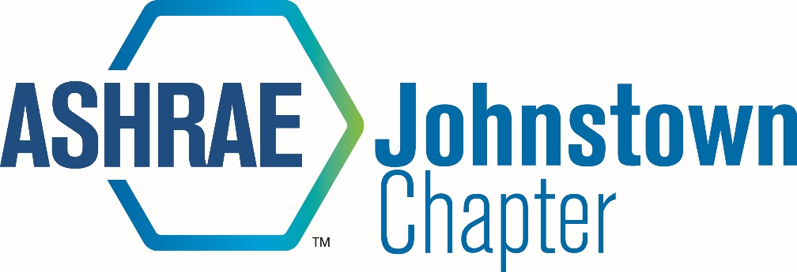

2017-2018 EXPENSE VOUCHER

TO: | JOHNSTOWN TREASURER  Mike Finnigan | DATE:

PAY TO:
ADDRESS:

NATURE OF EXPENSE: AMOUNT CLAIMED
 |  | $ | 0.00
 |  | $ | 0.00
 |  | $ | 0.00
 |  | $ | 0.00
 |  | $ | 0.00
 |  | $ | 0.00
 |  | $ | 0.00
 |  | $ | 0.00
 |  | $ | 0.00
 |  | $ | 0.00
TOTAL PAYMENT REQUEST |  | $ | 0.00
 | After entering all claim amounts, right-click on the Total Amount and click on the "Update Field" line and your total will add automatically

PRESIDENT: |  | DATE:
 | (Signature)
APPROVED FOR |  | DATE:
PAYMENT: | Treasurer (signature)

- Send this form to the President for his/her signature.
- All vouchers must be accompanied by original bills received and approved by President.

